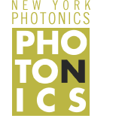 |  | The Rochester Cloak  Student Edition
Name: | Subject(s)/Course(s): Physical Science |  | Date:
Synopsis and Narrative:
You have been given the important task of destroying The One Ring that was created by the dark lord Sauron. Unfortunately, everyone is after this ring as it brings with it great evil powers. In order to keep the ring hidden at all times during your travels you must construct a Rochester Cloak. You must determine how large of an object the Rochester Cloak is able to hide and if it can completely hide the ring from your enemies during travel.
Challenging Question or Problem:
Cloaking is a device that can cause objects to become partially or wholly invisible within a certain section of the electromagnetic spectrum. How can we create one with convex lenses? How large of an object can we cloak?
Phenomenon and Manufacturing Application:
Optimax and QED Optics are the largest lens manufactures and manufactures of lens making equipment in the Rochester area.
Examples (in action):  Traditional cloaking devices that are operational have been developed outside of the visible spectrum. Examples include radar-absorbing dark paint, optical camouflage, and cooling to minimize infrared signatures. The military is constantly developing new stealth technology for aircraft, ships, vehicles, and soldiers.  Traditional cloaking or stealth devices include the F-117 nighthawk and USS Zumwalt destroyer.  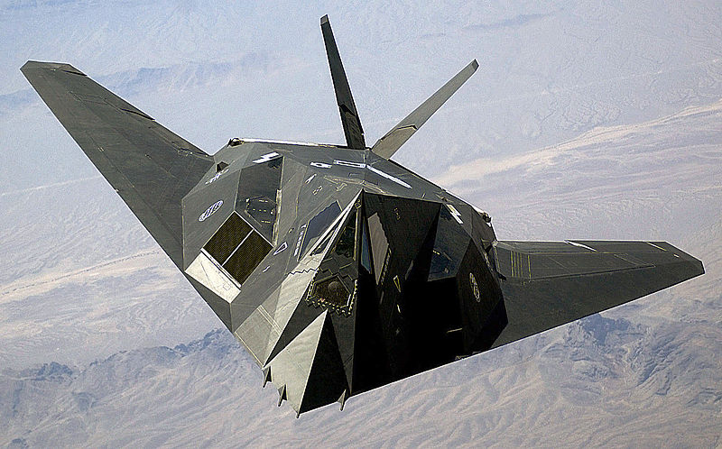  By Staff Sgt. Aaron Allmon II - http://www.defenselink.mil/, Public Domain, https://commons.wikimedia.org/w/index.php?curid=3770855  By (U.S. Navy photo courtesy of General Dynamics Bath Iron Works/Released) 151207-N-ZZ999-435 - https://www.flickr.com/photos/56594044@N06/22965290304/, CC BY 2.0, https://commons.wikimedia.org/w/index.php?curid=45537403 |  |  |  | Vocabulary:  Lens  Convex  Focal point  Focal length  Principal axis  Real image  Virtual image
State and National Standards & 21st Century Skills:
HS-PS4-6: Use mathematical models to determine relationships among the size and location of images, size and location of objects, and focal lengths of lenses and mirrors. Emphasis should be on analyzing ray diagrams to determine image size and location. Assessment Boundary: Assessment is limited to analysis of plane, convex, and concave mirrors, and biconvex and biconcave lenses.

Materials and Equipment:
2, 50mm, f=200mm convex lenses (could use lenses with a longer focal length if needed)
2, 50mm, f=50mm convex lenses

2 laser blox lasers (color ultimately does not matter but red and green is safer)
2, 3/8” x 1-1/2” washers to offset the lasers
1 optical tube assembly
Fog Machine (only if the activity is performed outside or in a room with heat detectors. DO NOT use fog machine in a room with smoke detectors).
1 metric ruler
Blank paper
Poster paper or receipt paper
Markers
Small pieces of paper or Post-it® notes.
Safety:
Lasers are light sources that can permanently damage the eye. They are not toys. When you are not using the laser, TURN IT OFF. Do not let the laser beam wander around the room. Always keep the laser beam below the chest area of all people in the room. Never look into the laser beam or at laser light reflected off of a shiny surface. If you stare into a laser beam for a period of time, permanent and irreparable damage to the eye can occur. The Laser Blox set provided in the kit is a Class IIIR laser product.
Learning Targets:
- Students will be able to explain how convex lenses in an optical assembly can be used to bend light so that it cloaks certain objects.
- Students will draw ray diagrams for convex lenses.
- Students will determine the relative size and location of an image as it goes through the optical assembly by analyzing the ray diagram.

Warmup: Individually answer the following questions.
Fictional Examples
- Cloaking devices are often used in popular media. Where have you seen cloaking devices used and in what context?
- ____________________________________________________________________________________________________________________________________________________________
- ____________________________________________________________________________________________________________________________________________________________
- ____________________________________________________________________________________________________________________________________________________________
- ____________________________________________________________________________________________________________________________________________________________
- ____________________________________________________________________________________________________________________________________________________________

Real Examples
- Traditional cloaking devices that are operational have been developed outside of the visible spectrum. Examples include radar-absorbing dark paint, optical camouflage, and cooling to minimize infrared signatures. Where have you seen real cloaking devices used and in what context?
- ____________________________________________________________________________________________________________________________________________________________
- ____________________________________________________________________________________________________________________________________________________________
- ____________________________________________________________________________________________________________________________________________________________

The Rochester Cloak
http://www.rochester.edu/newscenter/watch-rochester-cloak-uses-ordinary-lenses-to-hide-objects-across-continuous-range-of-angles-70592/

‘Cloaking’ device uses ordinary lenses to hide objects across range of angles
September 25, 2014
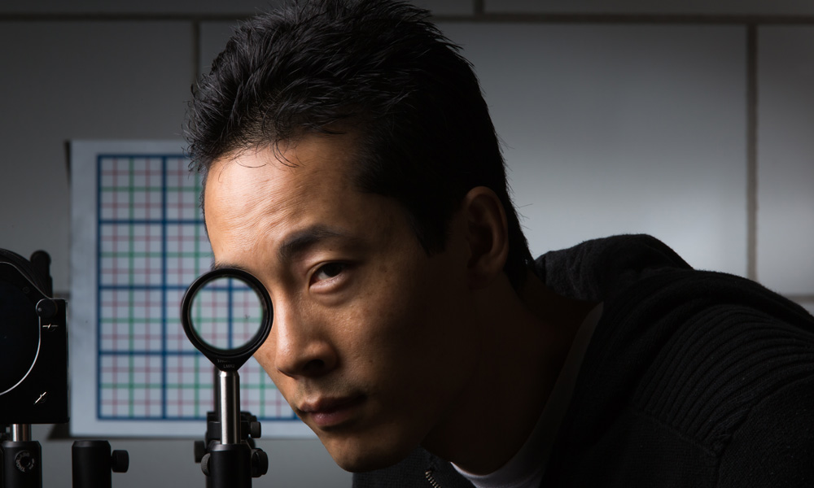Inspired perhaps by Harry Potter’s invisibility cloak, scientists have recently developed several ways—some simple and some involving new technologies—to hide objects from view. The latest effort, developed at the University of Rochester, not only overcomes some of the limitations of previous devices, but it uses inexpensive, readily available materials in a novel configuration.
“There’ve been many high tech approaches to cloaking and the basic idea behind these is to take light and have it pass around something as if it isn’t there, often using high-tech or exotic materials,” said John Howell, a professor of physics at the University of Rochester. Forgoing the specialized components, Howell and graduate student Joseph Choi developed a combination of four standard lenses that keeps the object hidden as the viewer moves up to several degrees away from the optimal viewing position.
Doctoral student Joseph Choi is pictured with a multidirectional `perfect paraxial’ cloak using 4 lenses.

“This is the first device that we know of that can do three-dimensional, continuously multidirectional cloaking, which works for transmitting rays in the visible spectrum,” said Choi, a PhD student at Rochester’s Institute of Optics.
Many cloaking designs work fine when you look at an object straight on, but if you move your viewpoint even a little, the object becomes visible, explains Howell. Choi added that previous cloaking devices can also cause the background to shift drastically, making it obvious that the cloaking device is present.
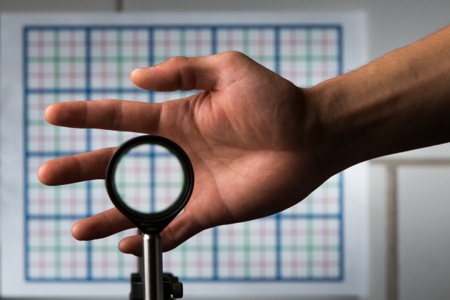In order to both cloak an object and leave the background undisturbed, the researchers determined the lens type and power needed, as well as the precise distance to separate the four lenses. To test their device, they placed the cloaked object in front of a grid background. As they looked through the lenses and changed their viewing angle by moving from side to side, the grid shifted accordingly as if the cloaking device was not there. There was no discontinuity in the grid lines behind the cloaked object, compared to the background, and the grid sizes (magnification) matched.
The Rochester Cloak can be scaled up as large as the size of the lenses, allowing fairly large objects to be cloaked. And, unlike some other devices, it’s broadband so it works for the whole visible spectrum of light, rather than only for specific frequencies.
A multidirectional `perfect paraxial’ cloak using four lenses. From a continuous range of viewing angles, the hand remains cloaked, and the grids seen through the device match the background on the wall (about 2 m away), in color, spacing, shifts, and magnification. // photo by J. Adam Fenster / University of Rochester

Their simple configuration improves on other cloaking devices, but it’s not perfect. “This cloak bends light and sends it through the center of the device, so the on-axis region cannot be blocked or cloaked,” said Choi. This means that the cloaked region is shaped like a doughnut. He added that they have slightly more complicated designs that solve the problem. Also, the cloak has edge effects, but these can be reduced when sufficiently large lenses are used.
In a new paper submitted to the journal Optics Express and available on arXiv.org [UPDATE 11/19/2014: The paper has now been published in Optics Express], Howell and Choi provide a mathematical formalism for this type of cloaking that can work for angles up to 15 degrees, or more. They use a technique called ABCD matrices that describes how light bends when going through lenses, mirrors, or other optical elements.
While their device is not quite like Harry Potter’s invisibility cloak, Howell had some thoughts about potential applications, including using cloaking to effectively let a surgeon “look through his hands to what he is actually operating on,” he said. The same principles could be applied to a truck to allow drivers to see through blind spots on their vehicles.
Howell became interested in creating simple cloaking devices with off-the-shelf materials while working on a holiday project with his children. Together with his 14 year-old son and Choi, he recently published a paper about some of the possibilities, and also demonstrated simple cloaking with mirrors, like magicians would use, in a brief video.
General description of the construction of a Rochester Cloak (procedure starts on next page):
- 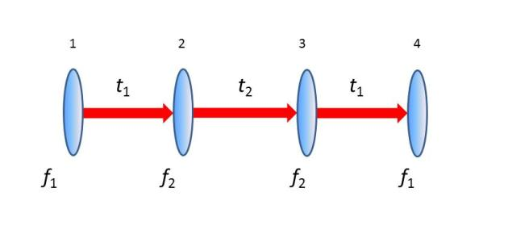You will need 2 sets of 2 lenses with different focal lengths f₁ and f₂ (4 lenses total, 2 with f₁ focal length, and 2 with f₂ focal length)
- Two sets of 2 lenses separated by the sum of their focal lengths (So f₁ lens is the first lens, f₂ is the 2nd lens, and they are separated by t₁= f₁+f₂). f₂ must have the smaller focal length.

- The two sets of lenses are separated by 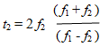 so that the two f₂ lenses are t₂ apart.

Vocabulary
- Lens
- Convex
- Focal point
- Focal length
- Principal axis
- Real image
- Virtual image

Analysis of a double convex lens:
You will be given two lasers and four lenses with two different focal lengths.

Laser Safety: Lasers are light sources that can permanently damage the eye. They are not toys. When you are not using the laser, TURN IT OFF. Do not let the laser beam wander around the room. Always keep the laser beam below the chest area of all people in the room. Never look into the laser beam or at laser light reflected off of a shiny surface. If you stare into a laser beam for a period of time, permanent and irreparable damage to the eye can occur.

- Using the two lasers stacked on top of each other, place the lens in the tube holder and align the lasers to the principle axis. Investigate how the light bends when the laser light passes through the lens. Place a small piece of paper or Post-it® note into the path of the laser, perpendicular to the ray, and observe the location of the laser at a point. Move the piece of paper towards the lens and then away. Using this method, along with a ruler, determine what the focal length is for each lens, record your results below.
Focal Lengths:
f₁=__________mm
f₂=__________mm

- Draw the path of the laser as it refracts through the lens in the box below. This is known as a ray diagram.
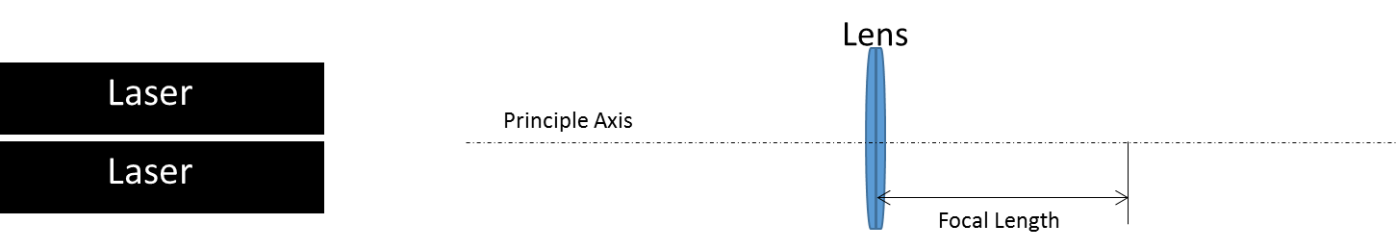

Constructing the Rochester Cloak
- Using the article above, calculate the distance between each lens (t₁ and t₂) in the space provided below.
Show all work.

- Determine the location where each lens needs to be placed in the tube so that the assembly is centered on the 40cm mark in the tube. Record those locations below.
Locations from left to right:
Lens 1=____cm, focal length of lens used = ____cm
Lens 2=____cm, focal length of lens used = ____cm
Lens 3=____cm, focal length of lens used = ____cm
Lens 4=____cm, focal length of lens used = ____cm

- Insert the lenses in the proper locations. This is done by putting each lens in at an angle and then adjusting it so that it is perpendicular to the principle axis. It is important that they are perpendicular to this axis as distortions in the image quality can occur if they are not positioned correctly.

When you have completed construction of the Rochester cloak look through the tube. If the image is distorted it is likely that you did something wrong.

- Using the two lasers stacked on top of each other, align the lasers to the principle axis with both the Cloak and the lasers resting on a table. Use the washers to raise the lasers so that they are centered on the principle axis. Investigate how the light refracts when it passes through the lenses and the Rochester cloak. Use your small piece of paper or Post-it® note to determine the location of the laser beams along the path.

- Draw a ray diagram of the Rochester cloak to scale using the provided paper. In your drawing note the following items.
- Principle axis
- Location of all four lenses with labels
- Location of the focal points for each lens with an x
- The two lasers
- The distance between each lens
- The laser beam as it passes through the apparatus

- Locate the cloaked areas on your drawing and determine where the ring should be placed. Label this area on your ray diagram. Place the ring inside of the cloak and close up the tube.

- Determine how large the cloaked region is and thus how large of an object you can hide.

- Determine the area of the cloaked region theoretically and then verify the cloaked region experimentally. Come up with a procedure for how you will do this.

